Python Lab 3 – NCL Decoding

Read the Cyber Aces Python modules for scripts <https://tutorials.cyberaces.org/tutorials/view/3-3-3.html>, and Introspection <https://tutorials.cyberaces.org/tutorials/view/3-3-4.html>. Python “introspection” is a fancy way of saying built-in help; it is useful.

This document, Python Hints for NCL Problems.docx, should prove useful 😉

# Hand in -- Solve these problems from a previous NCL

## There are three problems in Decoding 1; the values are just below the picture so you can copy and paste them into Python to solve them.

## Note: If you want to do the Decoding challenges from the current NCL, go ahead. Skip these problems and hand in the answers to the current NCL.

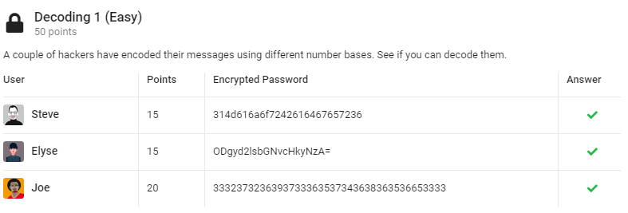

'314d616a6f7242616467657236'

'ODgyd2lsbGNvcHkyNzA='

'3332373236393733363537343638363536653333'

## There are three problems here too.

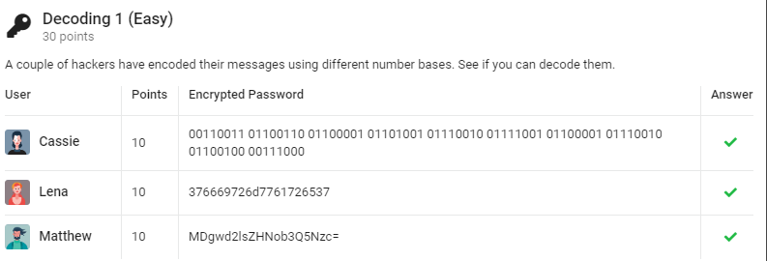

'00110011 01100110 01100001 01101001 01110010 01111001 01100001 01110010 01100100 00111000'

'376669726d7761726537'

'MDgwd2lsZHNob3Q5Nzc='